**CREATE AND CONFIGURE IBM CLOUD SERVICES**

***Create IBM Watson IOT Platform And Device:***

|  |  |
| --- | --- |
| Date | 22 September 2022 |
| Team ID | PNT2022TMID45285 |
| Project Name | **IoT Based safety gadget for child safety monitoring & Notification** |
| Maximum Marks | 4 Marks |

***Create IBM Watson IOT Platform And Device:***

**Created an Internet of Things (IoT) sensor device from a cell phone, hooked it up to the Watson IoT Platform for IBM Cloud.**

**Project Description:**

**Child tracker helps the parents in continuously monitoring the child’s location. They can simply leave their children in school or parks and create a geofence around the particular location. By continuously checking the child’s location notifications will be generated if the child crosses the geofence. Notifications will be sent according to the child’s location to their parents or caretakers. The entire location data will be stored in the database.**

**Many parents wouldn’t dream of letting their young children use an internet-connected device without some type of filter. It’s important to protect young web searchers from arriving at undesirable websites. An innocent enough search term could have a double meaning, leading impressionable minds to things better left unseen.**

**One approach for parents is to install software that restricts content on devices or a home router. Typically, if they’re not using a general rating scheme by age, parents need to know the sites they want to block ahead of time and set up their own block lists. This is time consuming, and chances are they’re going to miss something.**

**ChildRouter from Cloud-Nanny offers an automated and intelligent way to filter web content with a firewall-as-a-service (FaaS) solution. Parents choose which categories of sites they will allow their kids to see, and Cloud-Nanny handles almost everything else. The solution decides whether to allow or block web requests without noticeable effect on the user’s browsing experience. Using IBM dashDB, the processing check makes a request in Cloud-Nanny’s database and returns a decision is less than 40 microseconds.**

ChildRouter uses machine learning algorithms running in IBM Analytics for Apache Spark together with AlchemyAPI to classify and categorize content in nearly real time. If the system is unsure about a site, it checks with the parents. Using that input, the model learns and gets better at classifying that type of site in the future.

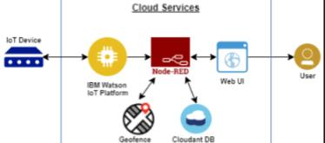WatchOver’s app and GPS tracker watch help ensure child safety.

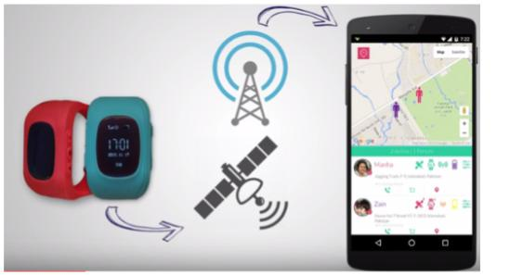

Many parents use apps to keep tabs on their children starting the day those children get their first smartphones.

Working parents can see that their children got on the bus in the morning and check on them after school, without needing to call or text. Parents of new drivers can have peace of mind knowing their children arrived safely where they said they would go.

But what about younger children who don’t have a smartphone?

That’s where WatchOver comes in. It’s a GPS tracker in a watch that enables parents to locate children through a smartphone app. For example, if a child were to get lost at a zoo or amusement park, a parent would be able to find out quickly where that child is.

What sets WatchOver apart is its safety insight. It incorporates current, local news so parents know what is going on in the vicinity of their children.

Software Productivity Strategists (SPS) developed WatchOver using the IBM Cloud, incorporating the Watson Alchemy Data News API. The back end is a node.js app hosted on the IBM Cloud, using the IBM Cloud IoT Foundation and the Geo-Spatial Analytics service.

Furthermore, the GPS tracker watch has both call receiving and dialing capabilities, as well as an SOS feature. In case of emergency, when the child presses the SOS button, it launches a call and message to three primary numbers registered as emergency contacts.

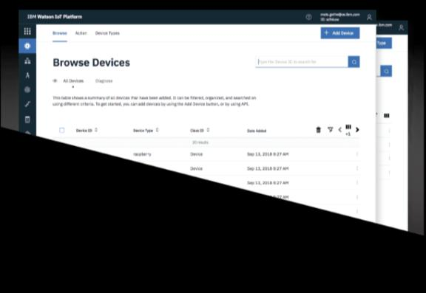Connect your device, send data to our cloud, set up and manage your devices, use APIs to connect apps to your device data.

